# 

# 

# 

**Populat.io**

**PROJECT COREPHASE**

DESIGN DOCUMENT

**TABLE OF CONTENTS**

**UML** **3**

**Sequence diagrams** **5**

**Use Case 1** **5**

**Use Case 2** **6**

**Use Case 3** **7**

**Use Case 4** **7**

**Use Case 5** **8**

# 

# UML

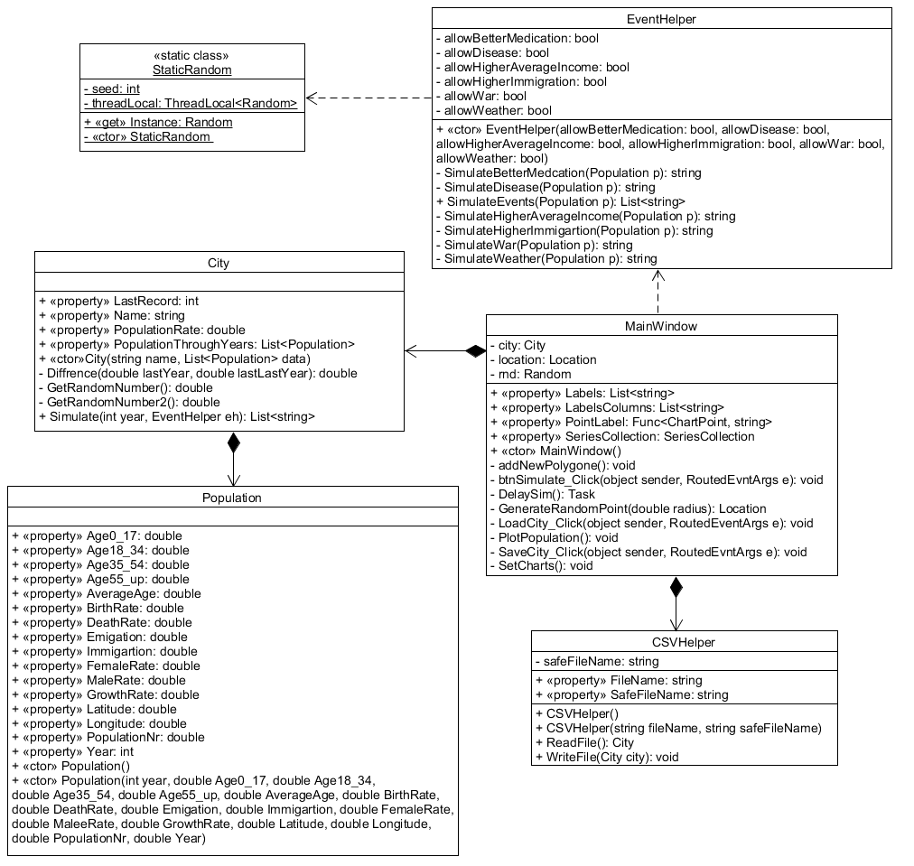

|  |  |
| --- | --- |
| **Class** | **Brief description** |
| Population | In it we store information regarding a city’s population, e.g. it’s demographical data. |
| City | The City class is used to create the city object thanks to the CSVHelper. The city class contains a subclass Population which loads the population statics needed for the simulation |
| MainWindow | This is the user interaction point with the app. This is the GUI. All of the functionality is focus here. This class allows the user to load and save currently loaded maps along with there statistics. |
| EventHelper | This class uses the StaticRandom class to help controlling the events. The class itself makes and sees which event where enabled from the MainWindow |
| CSVHelper | Used to load and save data to and from a csv file. |
| StaticRandom | Uses the environment tick to create a random value just to make it more unpredictable |

# Sequence diagrams

## Use Case 1

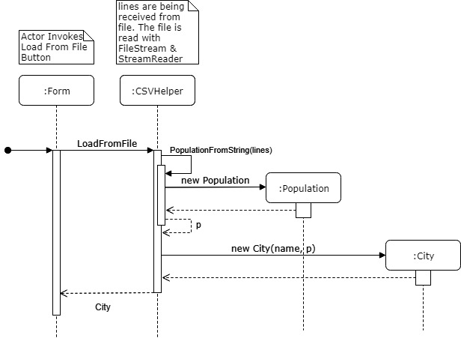

## Use Case 2

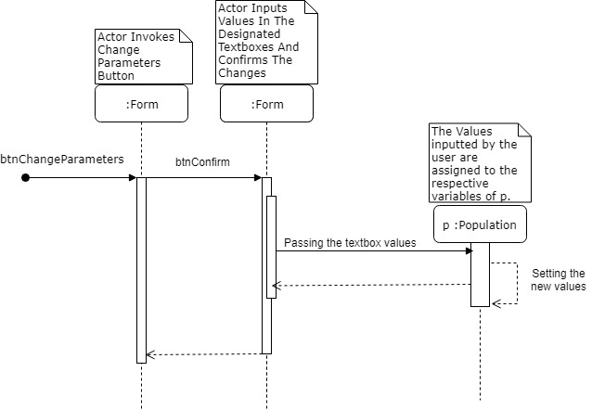

## Use Case 3

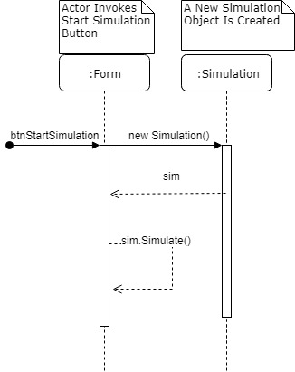

## Use Case 4

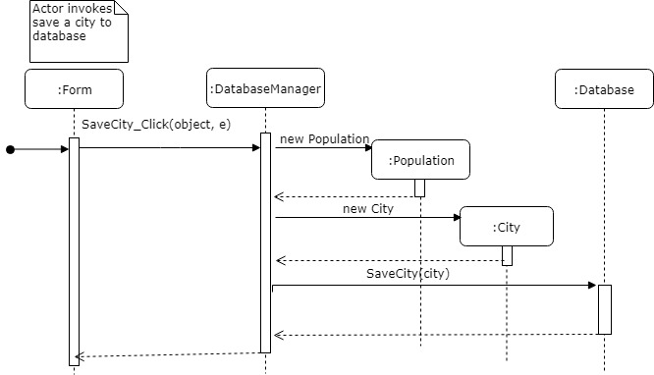

## Use Case 5

